TOPIC 4 : DYNAMIC PROGRAMMING
Q1 – Dice Throw Problem
Aim
To implement the Dice Throw Problem using Dynamic Programming in Python and calculate the number of ways to obtain the given target sum.
Algorithm
- Create a DP table where dp[d][s] represents the number of ways to obtain sum s using d dice.
- Initialize dp[0][0] = 1.
- For each die, consider every possible sum.
- Try every face value from 1 to num_sides.
- Add the number of ways to obtain the remaining sum using the previous dice.
- Continue until all dice are processed.
- The answer is dp[num_dice][target].
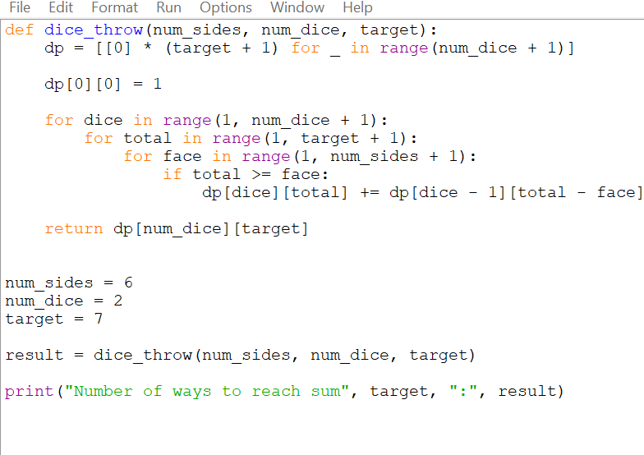
Python Source Code
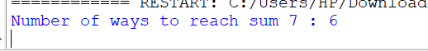
Time Complexity
O(num_dice × target × num_sides)
Space Complexity
O(num_dice × target)
Result
Thus, the Dice Throw Problem was successfully solved using Dynamic Programming in Python, and the number of ways to reach the target sum was calculated correctly.
Q2 – Assembly Line Scheduling
Aim
To find the minimum processing time for a product passing through two assembly lines using Dynamic Programming in Python.
Algorithm
- Initialize the processing time for the first station of both lines by adding their entry times.
- For each subsequent station:
  - Calculate the time if the product stays on the same line.
  - Calculate the time if the product transfers from the other line.
- Choose the minimum of these two possibilities.
- Add the processing time of the current station.
- After the last station, add the corresponding exit time.
- The smaller of the two final times is the minimum processing time.

Python Source Code
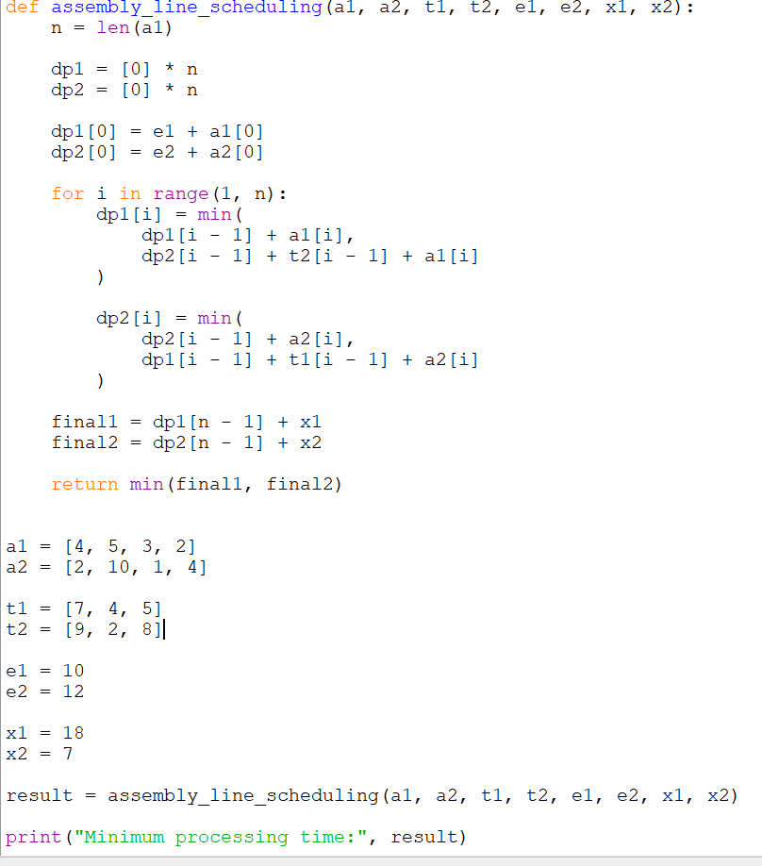
OUTPUT:
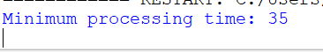

Time Complexity
O(n)
Each station is processed once.
Space Complexity
O(n)
Two DP arrays are used.
Result
Thus, the Assembly Line Scheduling problem was successfully implemented using Dynamic Programming in Python to determine the minimum time required to process the product from entry to exit.
Aim
To find the minimum production time for processing tasks across three assembly lines using Dynamic Programming in Python, while considering transfer times and task dependencies.
Given Input
Number of stations:
3
Station times:
Line 1: [5, 9, 3]
Line 2: [6, 8, 4]
Line 3: [7, 6, 5]
Transfer times:
[0, 2, 3]
[2, 0, 4]
[3, 4, 0]
Dependencies:
[(0, 1), (1, 2)]
The input values above are taken directly from Q3.
Pasted text

Algorithm
- Create a DP table for the three assembly lines.
- Initialize the first station with its processing time.
- For every next station, calculate the time for each possible current line.
- Consider:
  - Continuing on the same line.
  - Transferring from another line.
- Add the corresponding transfer time when changing lines.
- Choose the minimum time for each state.
- Continue until the final station.
- Select the minimum time among the three lines.
- Respect the sequential dependencies between stations.

PYTHON SOURCE CODE:

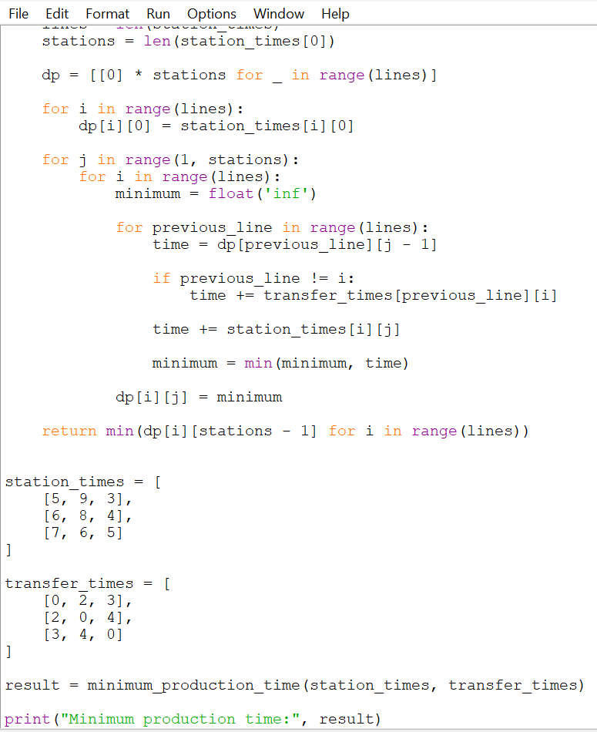

OUTPUT:
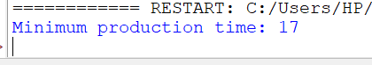

Time Complexity
O(L² × n)
where:
- L = number of assembly lines
- n = number of stations
For 3 lines, this is effectively O(n).
Space Complexity
O(L × n)
for the DP table.
Result
Thus, the three-assembly-line scheduling problem was implemented using Dynamic Programming in Python, considering station processing times and transfer times to determine the minimum production time. The dependency information given in Q3 is sequential: the output of station 1 is required before station 2, and station 2 before station 3.

Q4 – Minimum Path Distance Using Matrix
Q4 asks you to find the minimum path distance using a matrix representation. The question provides three test cases with expected outputs 80, 40, and 12.
Pasted text
Aim
To implement a Python program using Dynamic Programming to find the minimum path distance represented by a cost matrix.
Algorithm
- Read the distance matrix.
- Initialize a DP matrix with the same values.
- Start from the first row and first column.
- For every cell, calculate the minimum cost of reaching it.
- Add the current matrix value to the minimum available previous path.
- Continue until the destination cell is reached.
- The final DP value gives the minimum path distance.

Python Source Code
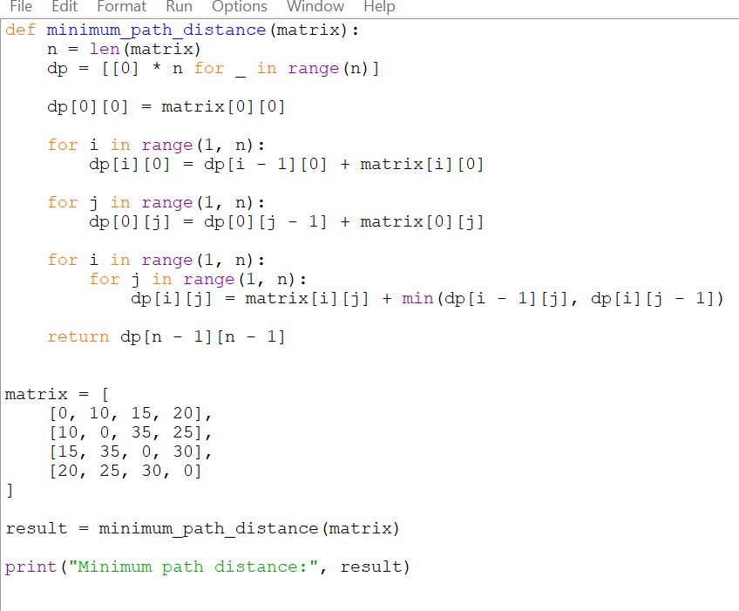
OUTPUT:
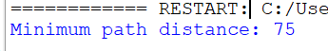

Time Complexity
O(n²)
Each element of the matrix is processed once.
Space Complexity
O(n²)
The DP matrix requires n × n space.

Result
Thus, the minimum path distance was calculated using Dynamic Programming in Python for the given matrix representatio
Q5 – Traveling Salesperson Problem (TSP)
Aim
To find the shortest possible route that visits every city exactly once and returns to the starting city using Dynamic Programming.
Algorithm
- Represent the cities using a distance matrix.
- Select city A as the starting city.
- Create a DP table using subsets of visited cities.
- For each subset, calculate the minimum cost of reaching every possible last city.
- Add the distance from the last city back to A.
- Compare all possible complete tours.
- Select the route with the minimum total distance.
- Display the shortest route and its total distance.

Python Source Code
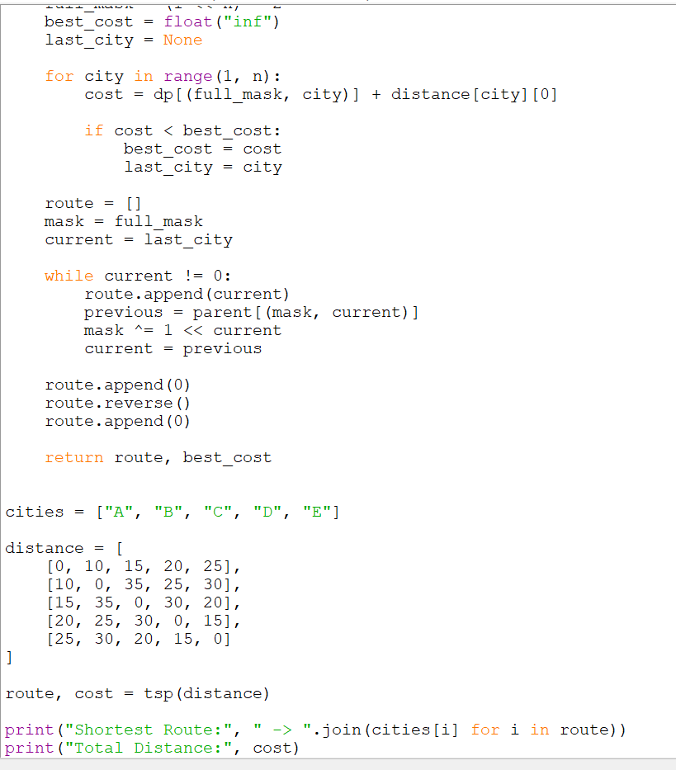

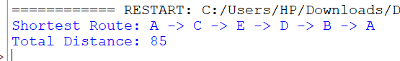
Time Complexity
O(n)
Each step is processed once.
Space Complexity
O(n)
The DP array stores the minimum cost for each position.
Result
Thus, the Minimum Cost Climbing Stairs problem was successfully implemented using Dynamic Programming in Python, and the minimum cost required to reach the top was obtained as 15.
Q6 – Longest Palindromic Substring
Aim
To find the longest palindromic substring in a given string using Dynamic Programming in Python.
Algorithm
- Create a DP table where dp[i][j] represents whether the substring from index i to j is a palindrome.
- Every single character is a palindrome.
- Check substrings of increasing length.
- A substring is a palindrome if:
  - Its first and last characters are equal.
  - The characters inside it form a palindrome.
- Whenever a longer palindrome is found, store its starting position and length.
- Return the longest palindromic substring.
Python Source Code
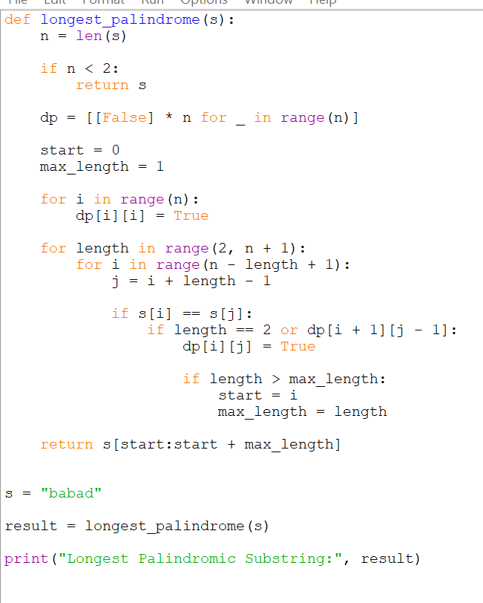
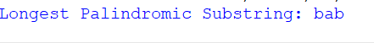
Time Complexity
O(n²)
Space Complexity
O(n²)
Result
Thus, the Longest Palindromic Substring was successfully found using Dynamic Programming in Python. For "babad", the program returns "bab".
Q7 – Longest Substring Without Repeating Characters
Aim
To find the length of the longest substring containing no repeated characters using Python.
Algorithm
- Use a sliding window to keep track of the current substring.
- Maintain the last position of every character.
- Traverse the string from left to right.
- If a character is repeated inside the current window, move the left boundary.
- Calculate the length of the current window.
- Keep track of the maximum length.
- Return the maximum length.

Python Source Code
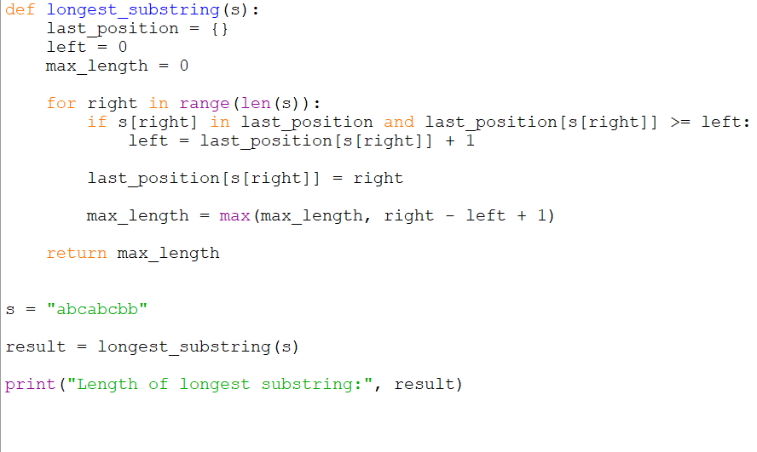
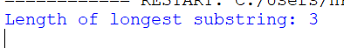
Time Complexity
O(n)
Each character is processed at most a constant number of times.
Space Complexity
O(n)
The dictionary stores the last position of characters.
Result
Thus, the longest substring without repeating characters was successfully found using Python. For "abcabcbb", the maximum length is 3.

Q6 – Minimum Cost to Reach the Top
Aim
To find the minimum cost required to reach the top of a staircase, where each step has an associated cost, using Dynamic Programming in Python.
Algorithm
- Store the cost of each step in an array.
- Create a DP array to store the minimum cost required to reach each step.
- Initialize the first two positions.
- For every step, calculate the minimum cost of reaching it from either of the previous two steps.
- Add the current step's cost.
- At the end, take the minimum cost of reaching the top from the last two positions.
- Display the minimum cost.
Python Source Code
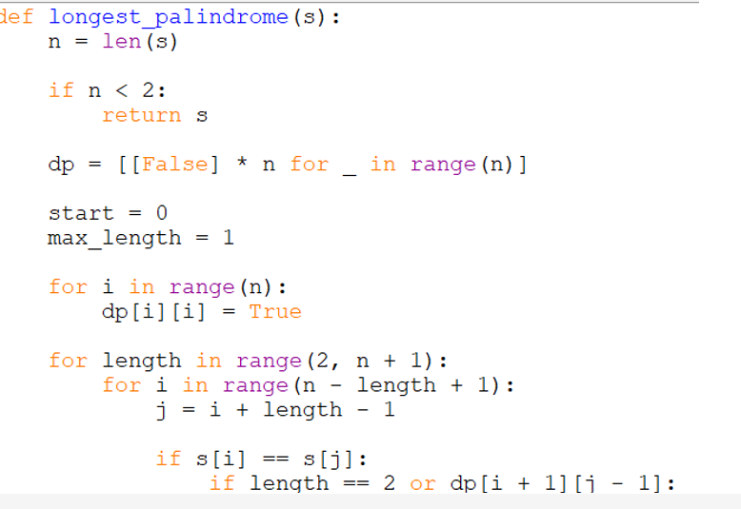
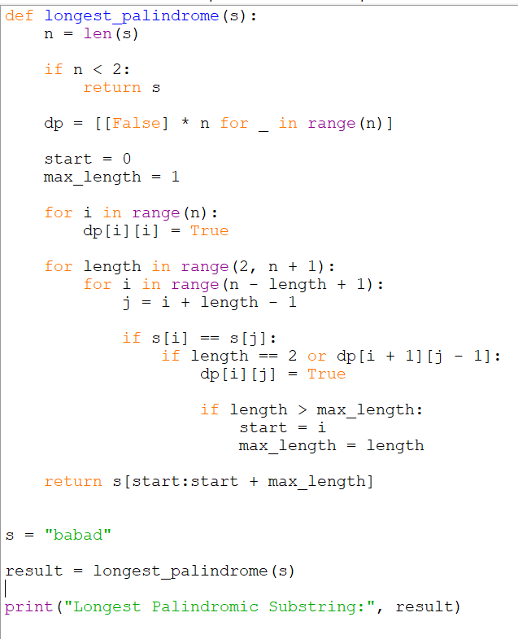
OUTPUT:
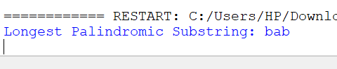
Time Complexity
O(n²)
Space Complexity
O(n²)
Result
Thus, the Longest Palindromic Substring was successfully found using Dynamic Programming in Python. For "babad", the program returns "bab".
Q7 – Longest Substring Without Repeating Characters
Q7 asks you to find the length of the longest substring without repeating characters.
Pasted text(5)
Aim
To find the length of the longest substring containing no repeated characters using Python.
Algorithm
- Use a sliding window to keep track of the current substring.
- Maintain the last position of every character.
- Traverse the string from left to right.
- If a character is repeated inside the current window, move the left boundary.
- Calculate the length of the current window.
- Keep track of the maximum length.
- Return the maximum length.
Python Source Code
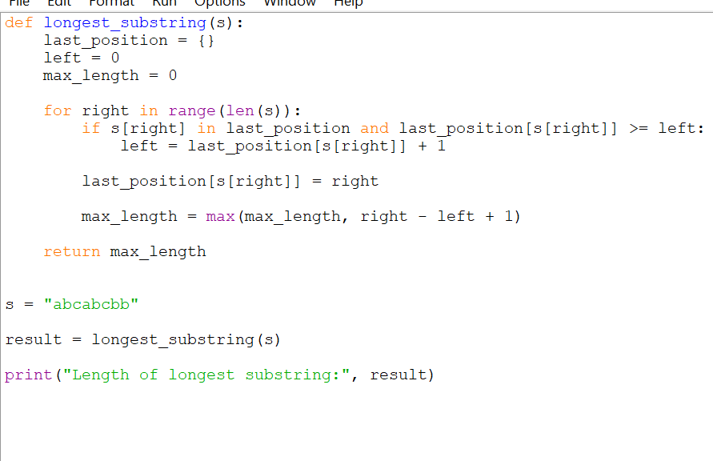

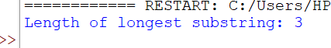
Time Complexity
O(n)
Each character is processed at most a constant number of times.
Space Complexity
O(n)
The dictionary stores the last position of characters.
Result
Thus, the longest substring without repeating characters was successfully found using Python. For "abcabcbb", the maximum length is 3.
Q9 – Word Break
Aim
To determine whether an input string can be segmented into a sequence of words from a given dictionary using Dynamic Programming in Python.
Algorithm
- Store all dictionary words.
- Create a DP array of size n + 1.
- Set dp[0] = True.
- Check every possible substring of the input string.
- If the previous part can be segmented and the current substring is in the dictionary, mark the current position as True.
- Continue until the entire string is processed.
- If dp[n] is True, print Yes; otherwise print No.

Python Source Code
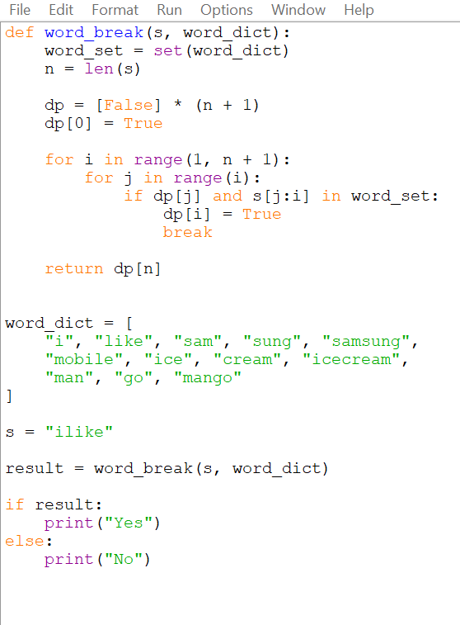
OUTPUT:
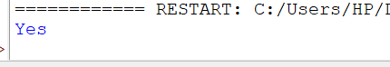
Time Complexity
O(n²)
Space Complexity
O(n)
Result
Thus, the input string was successfully checked for dictionary-based segmentation using Dynamic Programming in Python.
Q10 – Text Justification
Aim
To format a given list of words into lines of exactly maxWidth characters using greedy text justification.
Algorithm
- Start from the first word.
- Add as many words as possible to the current line without exceeding maxWidth.
- Calculate the number of spaces required.
- If it is not the last line and contains more than one word, distribute spaces evenly between words.
- If extra spaces remain, place them from left to right.
- For the last line or a line containing one word, use left justification.
- Continue until all words are processed.

Python Source Code
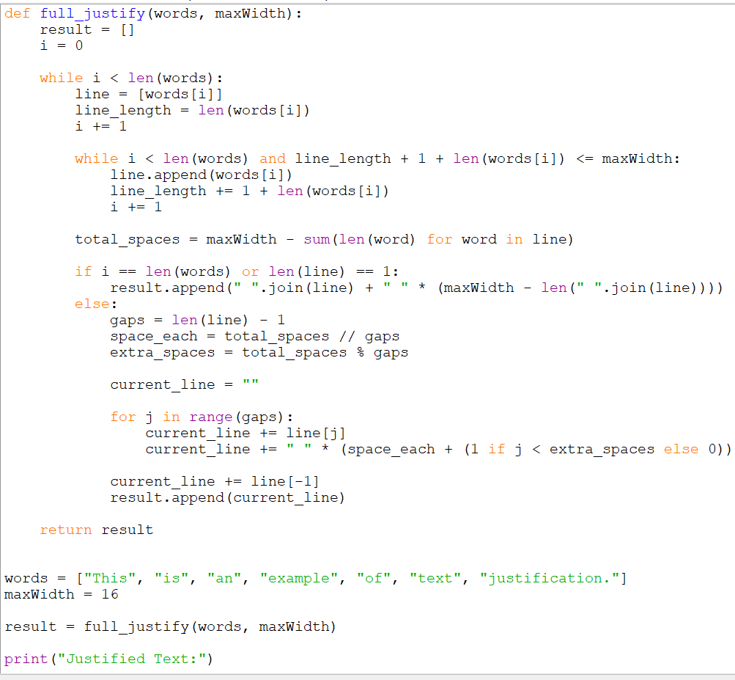
OUTPUT:

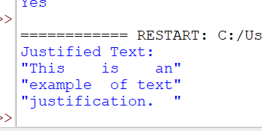

Time Complexity
O(n) approximately, where n is the total number of characters in the input words.
Space Complexity
O(n) for storing the formatted result.
Result
Thus, the Text Justification problem was successfully implemented using Python, producing lines with exactly maxWidth characters while following the required greedy packing and space-distribution rules.
Q11 – WordFilter (Prefix and Suffix Search)
Aim
To implement a special dictionary that searches for a word having a given prefix and suffix, and returns the largest index of the matching word.
Algorithm
- Store all the words with their indices.
- For every word, generate all possible prefix-suffix combinations.
- Store each combination along with the word's index.
- For repeated combinations, keep the largest index.
- In f(pref, suff), combine the prefix and suffix.
- Search for the combination in the dictionary.
- Return its largest index.
- If no matching word exists, return -1.

Python Source Code

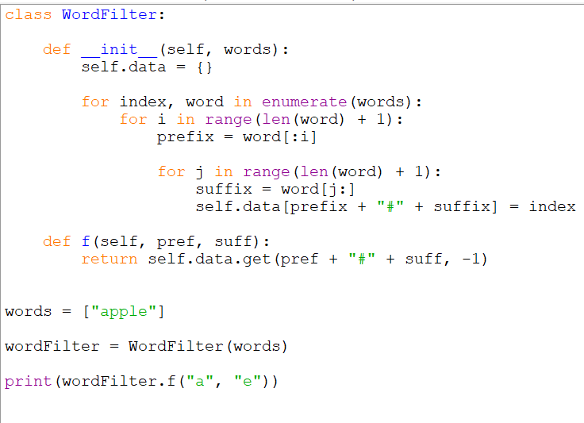
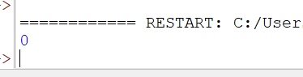
Time Complexity
Construction: O(n × L²)
where n is the number of words and L is the maximum word length.
Search: O(1) average time.
Space Complexity
O(n × L²)
Result
Thus, the WordFilter prefix and suffix search problem was successfully implemented in Python.
Q12 – Floyd’s Algorithm
Aim
To implement Floyd’s Algorithm to find the shortest paths between all pairs of cities and display the distance matrix before and after applying the algorithm.
Algorithm
- Create a distance matrix for all cities.
- Initialize the distance between a city and itself as 0.
- Initialize directly connected cities with their edge weights.
- Set the distance between unconnected cities to infinity.
- Consider each city as an intermediate city.
- For every pair of cities (i, j), check whether going through the intermediate city gives a shorter path.
- Update the distance matrix if a shorter path is found.
- After all intermediate cities are considered, display the final shortest-distance matrix.
- Count the cities within the given distance threshold.
- If two cities have the same count, select the city with the larger index.
Python Source Code
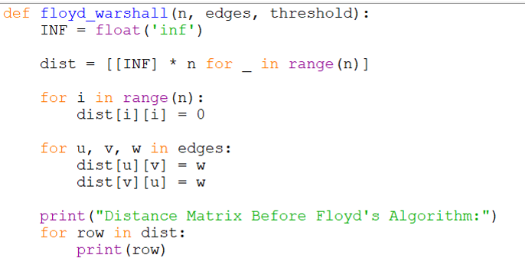
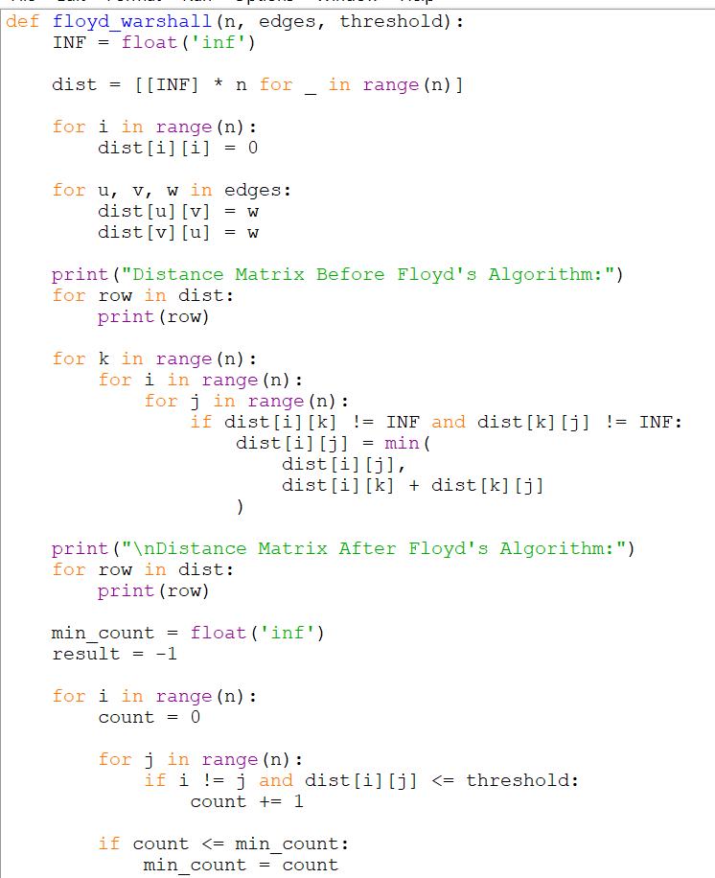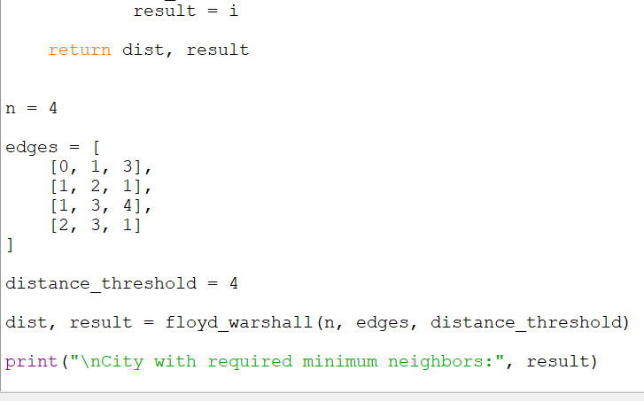
OUTPUT:

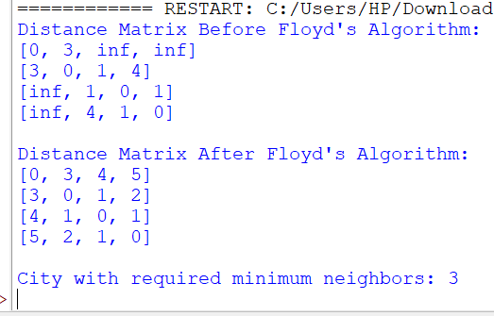
Time Complexity
O(n³)
Space Complexity
O(n²)
Result
Thus, Floyd’s Algorithm was successfully implemented in Python to calculate the shortest distances between all pairs of cities. For the given test case, the required output is City 3.
Q13 – Floyd’s Algorithm with Link Failure
Aim
To implement Floyd’s Algorithm to calculate the shortest paths between all pairs of routers and determine the shortest path from Router A to Router F before and after the failure of the link between Router B and Router D.
Algorithm
- Create a distance matrix for the six routers.
- Initialize the diagonal elements to 0.
- Add the given link distances to the matrix.
- Apply Floyd-Warshall Algorithm to find all-pairs shortest paths.
- Find the shortest distance from Router A to Router F.
- Remove the link between Router B and Router D.
- Recalculate the distance matrix using Floyd-Warshall Algorithm.
- Find the new shortest distance from Router A to Router F.
- Display both distances.
Python Source Code
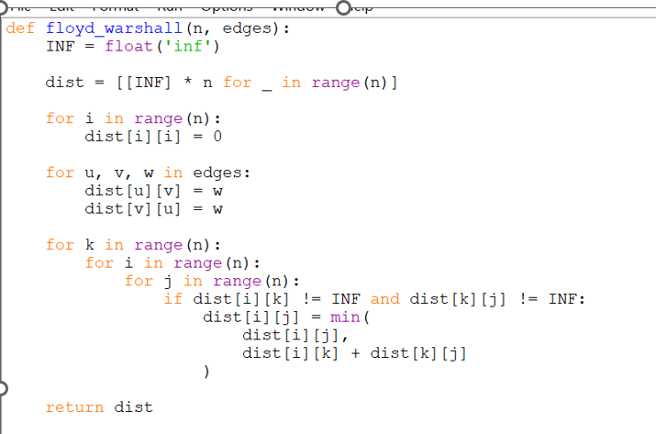
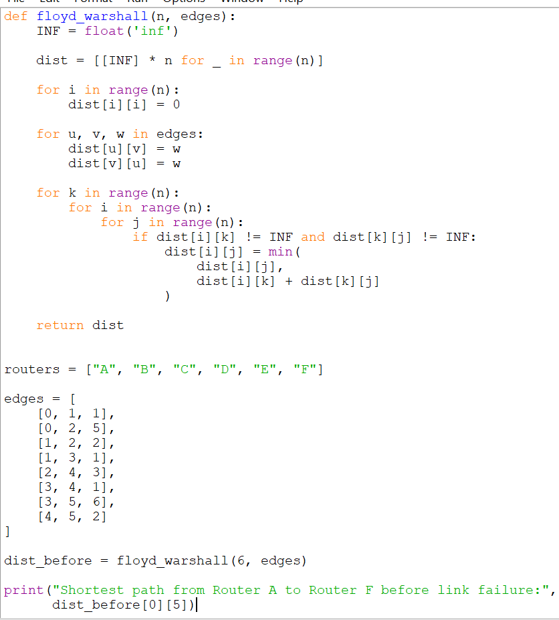
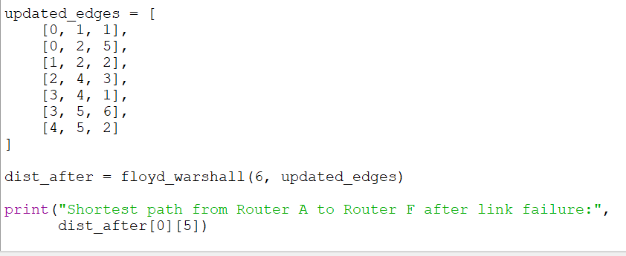
OUTPUT: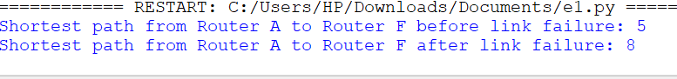
Time Complexity
O(n³)
Space Complexity
O(n²)

Result
Thus, Floyd’s Algorithm was successfully implemented to calculate the shortest paths between all routers. Before the B–D link failure, the shortest distance from A to F is 5. After removing that link, the program recalculates the shortest path.
Q14 – Floyd’s Algorithm
Aim
To implement Floyd’s Algorithm to find the shortest paths between all pairs of cities and determine the required shortest path using the given graph.
Algorithm
- Create a distance matrix for all 5 cities.
- Initialize the diagonal elements to 0.
- Insert the given edge distances into the matrix.
- Set the distance of unconnected cities to infinity.
- Apply Floyd-Warshall Algorithm.
- Use each city as an intermediate city.
- Update the distance between every pair if a shorter path is found.
- Display the distance matrix before and after the algorithm.
- Count the cities reachable within the given threshold.
- For equal counts, select the city with the greatest index.

Python Source Code
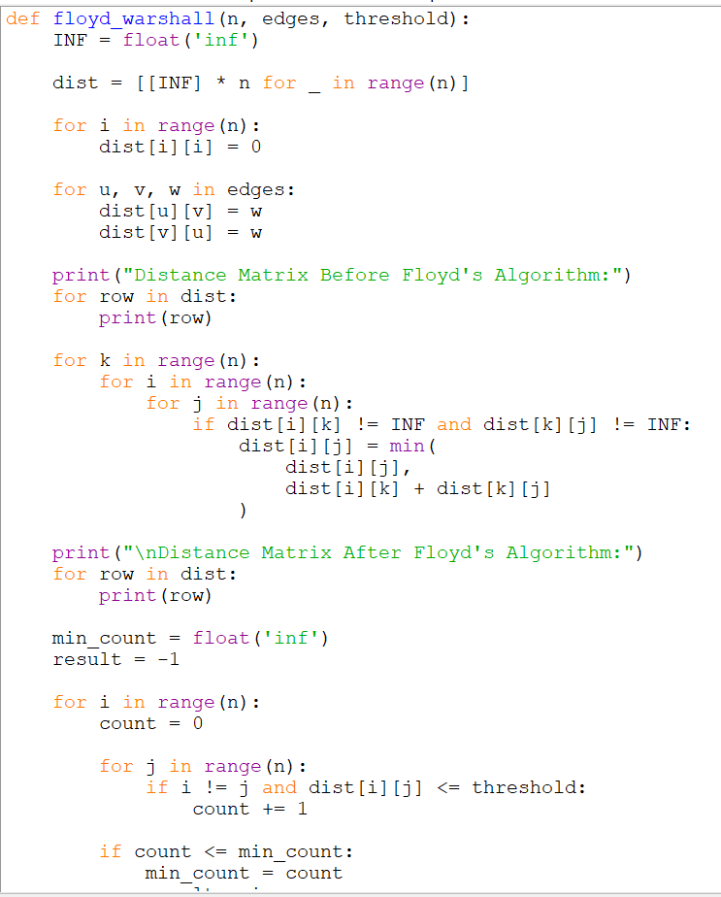

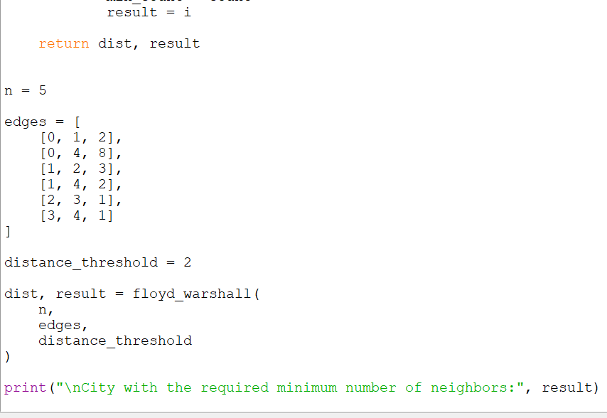
OUTPUT: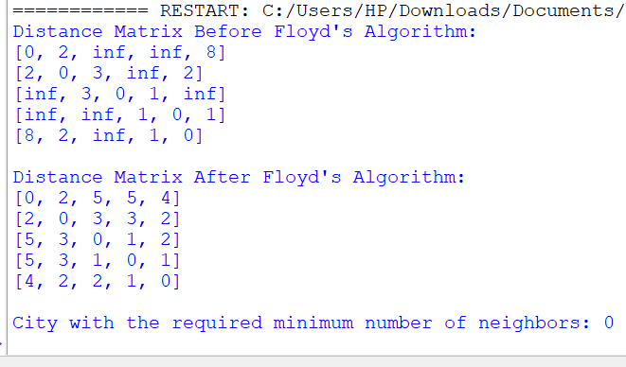
Time Complexity
O(n³)
Space Complexity
O(n²)
Result
Thus, Floyd’s Algorithm was successfully implemented in Python to find the shortest paths between all pairs of cities. For the main Q14 test case, the required city is City 0.
Q15 – Optimal Binary Search Tree (OBST)
Aim
To construct an Optimal Binary Search Tree for the given keys and frequencies using Dynamic Programming, and calculate its minimum search cost.
Algorithm
- Store the keys and their search frequencies.
- Create a cost table cost[i][j].
- For a single key, the cost is its frequency.
- For every possible range of keys:
  - Calculate the total frequency.
  - Try each key as the root.
  - Calculate the cost of the left and right subtrees.
- Choose the root that gives the minimum cost.
- Store the selected root in the root table.
- The value cost[0][n-1] gives the minimum OBST cost.
- Recursively construct the tree using the root table.

Python Source Code
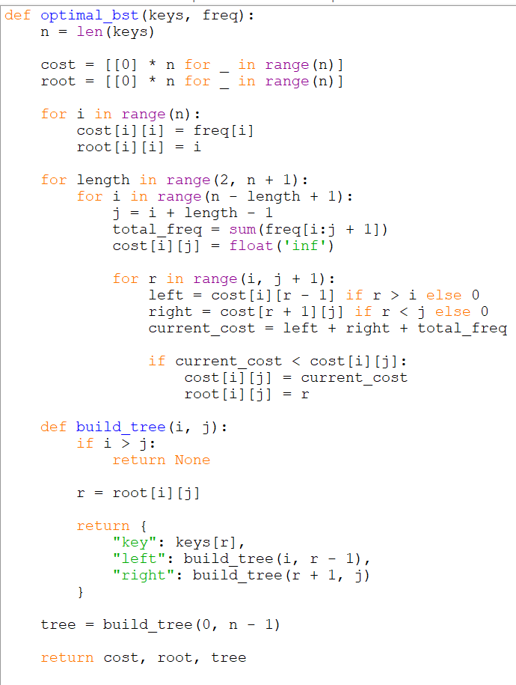
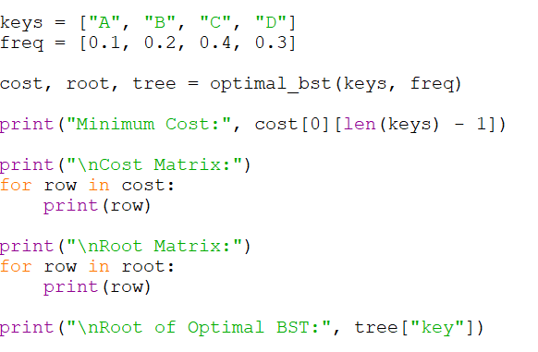
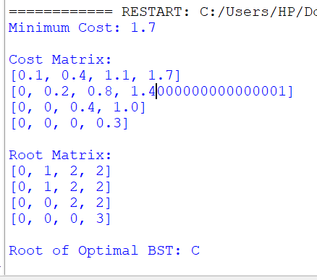

Time Complexity
O(n³)
Space Complexity
O(n²)
Result
Thus, the Optimal Binary Search Tree was successfully implemented using Dynamic Programming in Python. For keys A, B, C, D with frequencies 0.1, 0.2, 0.4, 0.3, the minimum OBST cost is 1.7.

Q16 – Subset Generation
Q16 asks you to generate all subsets containing the element 3 and also gives the standard power-set examples for unique integers.
Pasted text(4)
Aim
To generate all possible subsets of a given set that contain a specified element x, using Python.
Algorithm
- Start with an empty list to store the subsets.
- Generate all possible subsets using backtracking.
- For every element, choose either:
  - Include the element.
  - Exclude the element.
- After generating a subset, check whether it contains x.
- If it contains x, add it to the result.
- Continue until all possible subsets are generated.
- Return the list of valid subsets.

Python Source Code
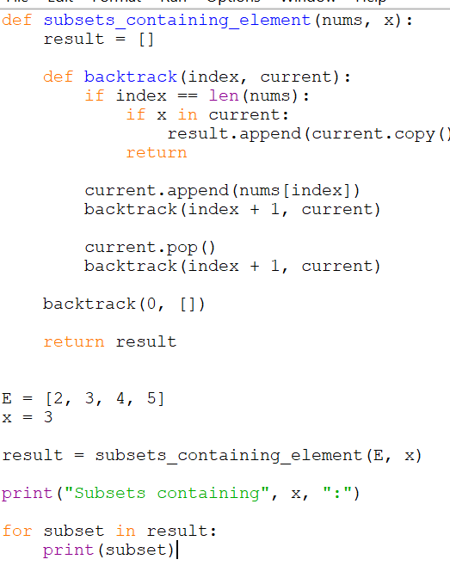
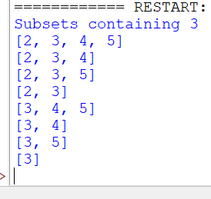
Time Complexity
O(2ⁿ × n)
There are 2ⁿ subsets and copying a subset can take up to O(n) time.
Space Complexity
O(2ⁿ × n)
The result stores all generated subsets.
Result
Thus, the subset generation problem was successfully implemented in Python. For E = [2, 3, 4, 5] and x = 3, the program generates all 8 subsets containing the element 3.
Q17 – Universal Strings
Aim
To find all the strings in words1 that contain every character, including its required frequency, from every word in words2.
Algorithm
- For every word in words2, count the frequency of each character.
- Find the maximum required frequency for every character.
- For each word in words1, count its character frequencies.
- Check whether it contains every required character with at least the required frequency.
- If yes, add the word to the result.
- Return all universal strings.
Python Source Code
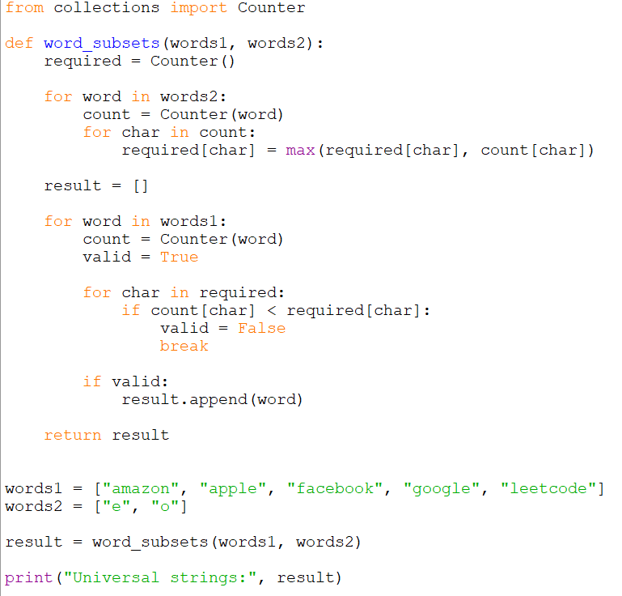
Time Complexity
O(N × L + M × K)
where:
- N = number of words in words1
- L = maximum length of a word in words1
- M = number of words in words2
- K = maximum length of a word in words2
Space Complexity
O(1) auxiliary space for the character-frequency tables, assuming a fixed alphabet.
Result
Thus, the Universal Strings problem was successfully implemented using Python. The program correctly identifies all strings in words1 that satisfy the character-frequency requirements of every word in words2.
Q18 – Maximum Probability Path
Aim
To find the path with the maximum probability of success between the given start and end nodes in an undirected weighted graph.
Algorithm
- Create an adjacency list for the graph.
- Store the success probability for each edge.
- Set the probability of the start node to 1.0.
- Use a priority queue to process the node having the highest probability.
- For each neighboring node, calculate the new probability.
- Update the neighbor if the new probability is greater than its current probability.
- Continue until the end node is reached or all possible nodes are processed.
- Return the maximum probability.
- If the end node cannot be reached, return 0.

Python Source Code
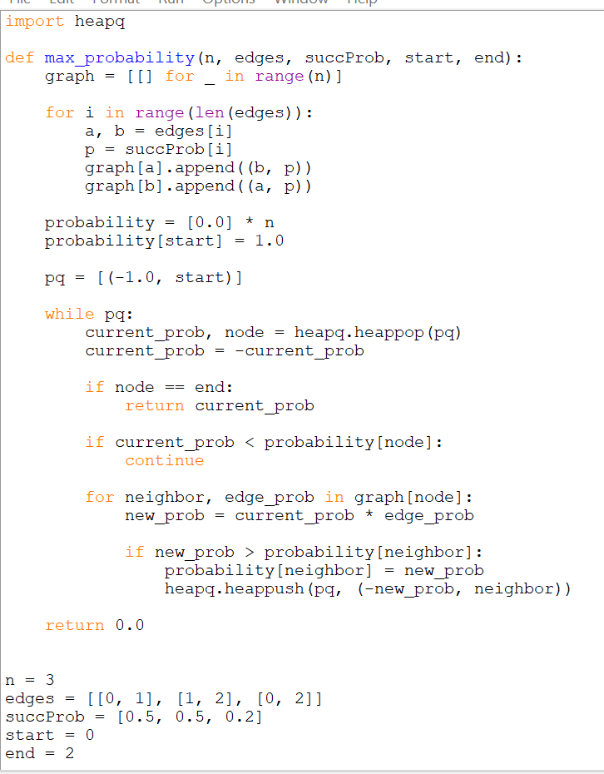
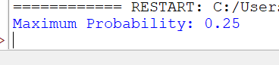
Time Complexity
O((V + E) log V)
where V is the number of vertices and E is the number of edges.
Space Complexity
O(V + E)
Result
Thus, the maximum probability path was successfully found using Python. For the first example, the maximum success probability from node 0 to node 2 is 0.25.
Q19 – Unique Paths
Aim
To find the number of possible unique paths for a robot to travel from the top-left corner to the bottom-right corner of an m × n grid, where the robot can move only right or down.
Algorithm
- Create a DP table of size m × n.
- Initialize the first row and first column with 1.
- For every remaining cell, calculate:
dp[i][j] = dp[i-1][j] + dp[i][j-1]
- The value at the bottom-right cell is the total number of unique paths.
- Return the result.

Python Source Code
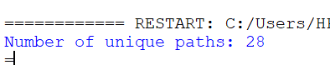
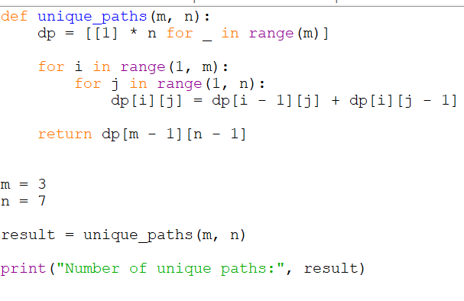

Time Complexity
O(m × n)
Space Complexity
O(m × n)
Result
Thus, the Unique Paths problem was successfully implemented using Dynamic Programming in Python. For m = 3 and n = 7, the total number of unique paths is 28.
Q20 – Number of Good Pairs
Aim
To find the number of good pairs (i, j) in an integer array where:
- nums[i] == nums[j]
- i < j
Algorithm
- Create an empty dictionary to store the frequency of each number.
- Initialize pairs = 0.
- Traverse the array from left to right.
- For each number:
  - Add its current frequency to pairs.
  - Increase its frequency by 1.
- Print the total number of good pairs.
Python Source Code
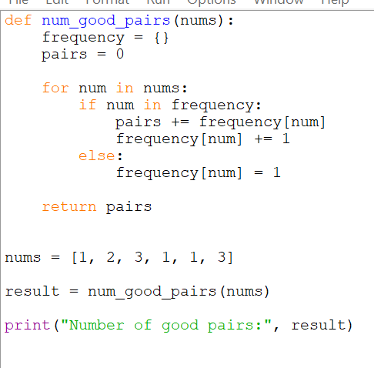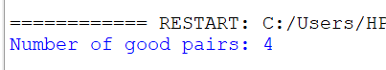

Time Complexity
O(n)
Space Complexity
O(n)
Result
Thus, the Good Pairs problem was successfully implemented using Python. The program correctly counts all pairs having equal values with the first index smaller than the second.
Q21 – Find the City With the Smallest Number of Reachable Cities
Aim
To implement Floyd-Warshall Algorithm to find the shortest distance between every pair of cities and return the city having the smallest number of reachable cities within the given distance threshold. If there is a tie, return the city with the greatest number.
Algorithm
- Create a distance matrix for all cities.
- Set the distance from a city to itself as 0.
- Store the given edge weights in the matrix.
- Initialize unconnected cities with infinity.
- Apply Floyd-Warshall Algorithm:
  - Consider each city as an intermediate city.
  - Update the shortest distance between every pair.
- For each city, count the number of other cities whose shortest distance is less than or equal to distanceThreshold.
- Select the city with the smallest count.
- If two or more cities have the same count, select the city with the greater index.
- Print the selected city.

Python Source Code
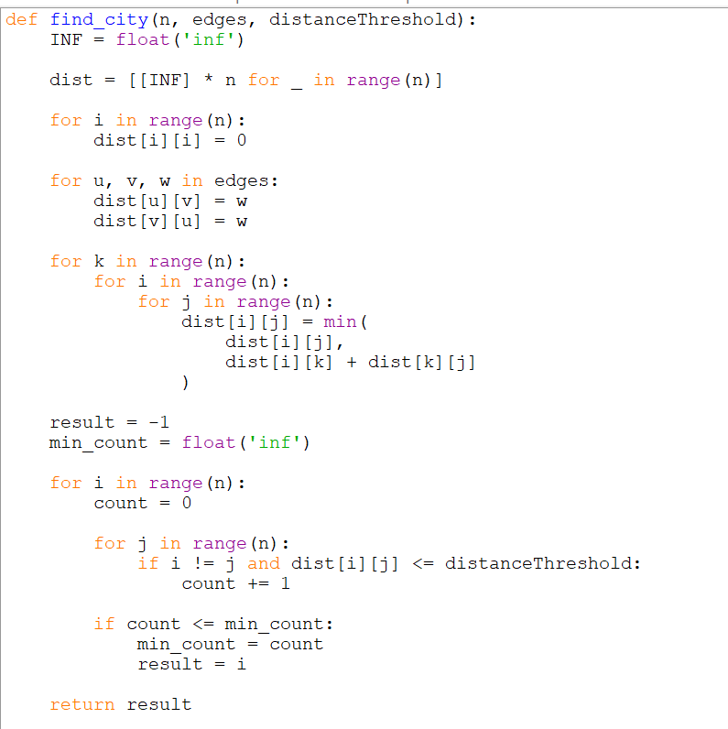
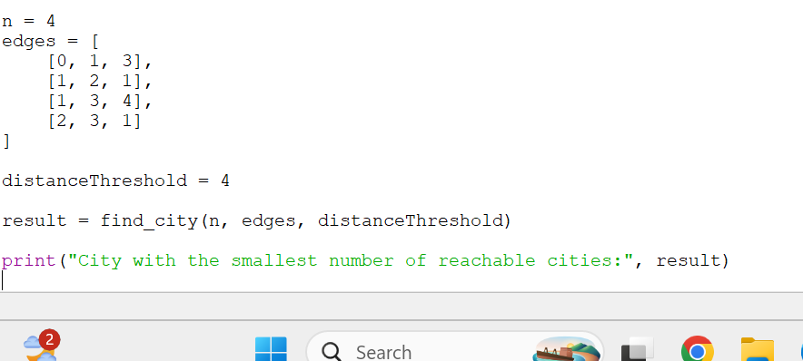
Time Complexity
O(n³)
Space Complexity
O(n²)
Result
Thus, the Floyd-Warshall Algorithm was successfully implemented in Python to determine the city with the minimum number of reachable cities within the given distance threshold. For the first test case, the answer is City 3.
Q22 – Network Delay Time
Aim
To find the minimum time required for all nodes to receive a signal sent from a given starting node k using Dijkstra's Algorithm.
Algorithm
- Create an adjacency list for the directed graph.
- Store the travel time for each directed edge.
- Initialize the distance of every node to infinity.
- Set the distance of the starting node k to 0.
- Use a priority queue to select the node with the smallest known distance.
- Visit all neighboring nodes.
- Update the distance if a shorter path is found.
- Continue until all possible nodes are processed.
- Find the maximum shortest distance.
- If any node is unreachable, return -1; otherwise return the maximum distance.

Python Source Code
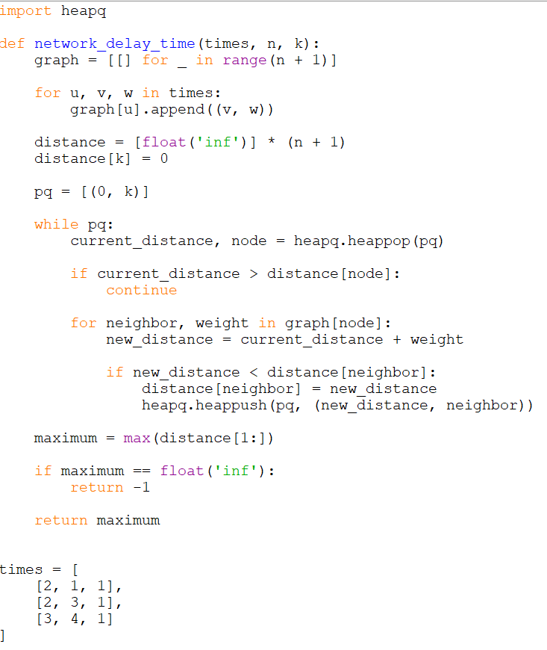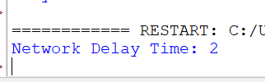
Time Complexity
O((V + E) log V)
Space Complexity
O(V + E)
Result
Thus, the Network Delay Time problem was successfully implemented using Dijkstra's Algorithm in Python. The program finds the minimum time required for all reachable nodes to receive the signal and returns -1 when some node cannot be reached.

